Katherine Stanton
Assignment 08
ITAI-2373 - NLP
Professor Narges DeBary

Assignment 08 – Named Entity Recognition (NER)
Introduction
Named Entity Recognition (NER) is a subtask of NLP that usually takes place after the text preprocessing, parsing, and Part-of-Speech (POS) tagging stages. NER works by recognizing entities - (which can include a person/ place/ or thing, as well as many more specific or custom entities like time or organizations) - in each text and assigning the entity to predetermined categories. I’ll be expanding on how NER works and its applications below.
Discussion
According to IBM ^{[2]}, NER grew out of the demand for a streamlined information extraction process - while dealing with high volumes of text data that was unstructured and uncategorized. NER models work by first detecting a named entity which can be a single word or a group of words and then categorizing the entity. As IBM notes, entities are not limited to person, place, or things, but can include types of money, medical codes, organizations, time, quantities or custom labels depending on use case.
Turing lists several methodologies for NER in their comprehensive guide ^{[3]} of the subject. These include:
- Dictionary-based methods – utilizes a dictionary to match words, which is not often used due to the dictionary needing to be updated and maintained.
- Rule-based methods – works by creating a set of rules for extracting data which can be either pattern-based or context-based depending on need.
- ML-based methods - first trains a machine learning model with annotated documents, then the trained model is used to annotate raw documents.
- And Deep Learning-based methods – More accurate than ML models, this method uses neural networks like recurrent NNs and LSTM (long short-term memory) RNNs or transformer models like SpaCy and BERT.
To implement a NER system, many companies use NER APIs (application programming interfaces). These include NLTK (Natural Language Toolkit), Stanford Named Entity Recognizer, and SpaCy.
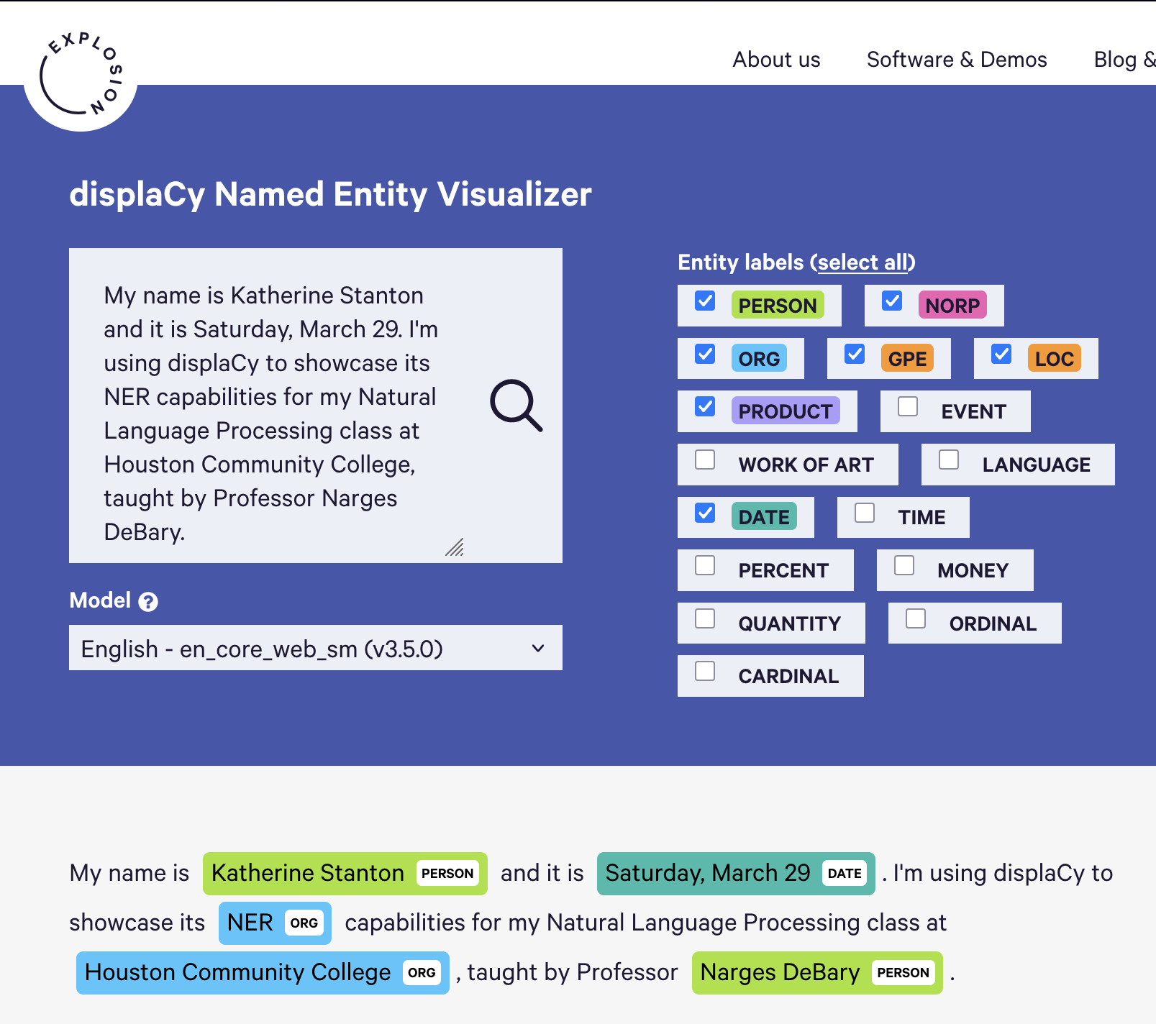
Figure 1. displaCy online tool ^{[1]}
SpaCy’s web-based visualizer tool above demonstrates how entities are tagged and categorized. Interestingly, NER is incorrectly tagged as an organization perhaps due to it being an abbreviated acronym.

Conclusion
NER is becoming an omnipresent part of modern NLP and AI with its useful methods of information extraction and categorization. It is being used in a variety of applications including customer service, the medical field, improving the accuracy of search engines, chatbots, and virtual assistants, and even in cybersecurity. Being able to use SpaCy’s web tool was a helpful demonstration of how these models work to categorize named entities and I look forward to experimenting more with other available models in the future.

References
- Explosion AI. (n.d.). displaCy Named Entity Visualizer demo. Explosion AI.
https://demos.explosion.ai/displacy-ent
- IBM. (2023, August 26). What is named entity recognition? IBM.
https://www.ibm.com/think/topics/named-entity-recognition
- Turing. (n.d.) A Comprehensive Guide to Named Entity Recognition (NER). Turing.
https://www.turing.com/kb/a-comprehensive-guide-to-named-entity-recognition

